**CRM Application For Jewel Management**

College Name: AVP College Of Arts And Science

College Code:bruaj

Team ID: NM2025TMID25446

**TEAM MEMBERS:**

**Team Leader Name:**  ARIYADHARSHINI.P

**Email:** ariyadharshiniprabhu@gmail.com

**Team Member1:** JANCY

**Email:**  jancyrathinam4@gmail.com

**Team Member:**  MOHANA PRIYA

**Email**: mohanapriyav2205@gmail.com

**Team Member:** SWETHA.M

**Email:** swethamurugesan017@gmail.com

**1.INTRODUCTION**

**1.1 Overview of CRM Application for Jewel Management**

**Customer Relationship Management (CRM)** is a strategic approach and accompanying software designed to manage, analyze, and enhance interactions with current and prospective customers. At its core, a CRM centralizes customer data including contact details, communication history, and behavior while providing tools for sales, marketing, and support automation to boost engagement, retention, and business growth.

**DEVELOPMENT PHASE**

Creating Developer Account

By using this URL - <https://developer.salesforce.com/signup>

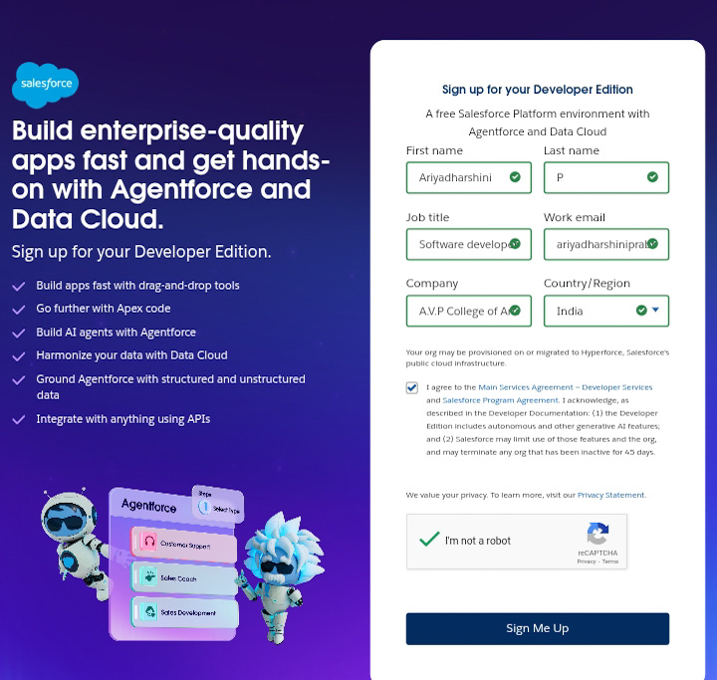

* Created Objects: Jewel Customer, Item, Customer Order, Price and Billing.

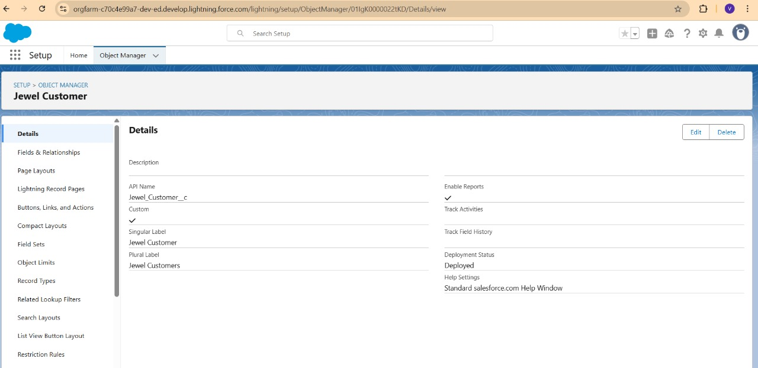

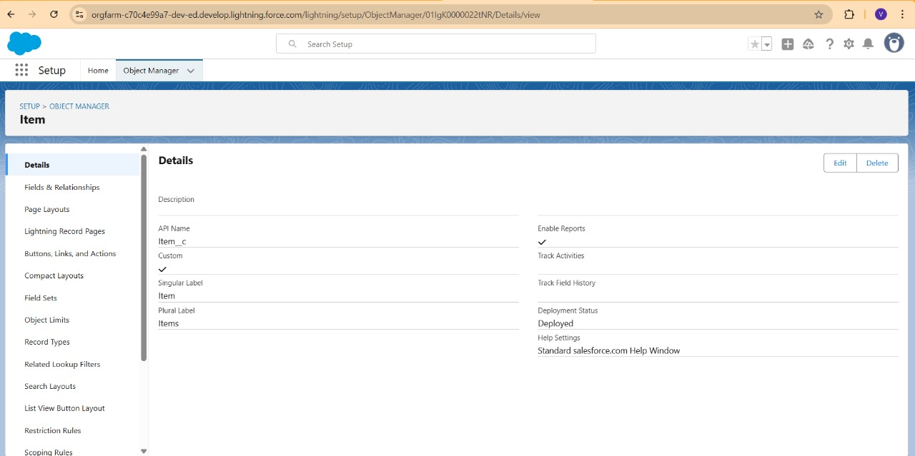

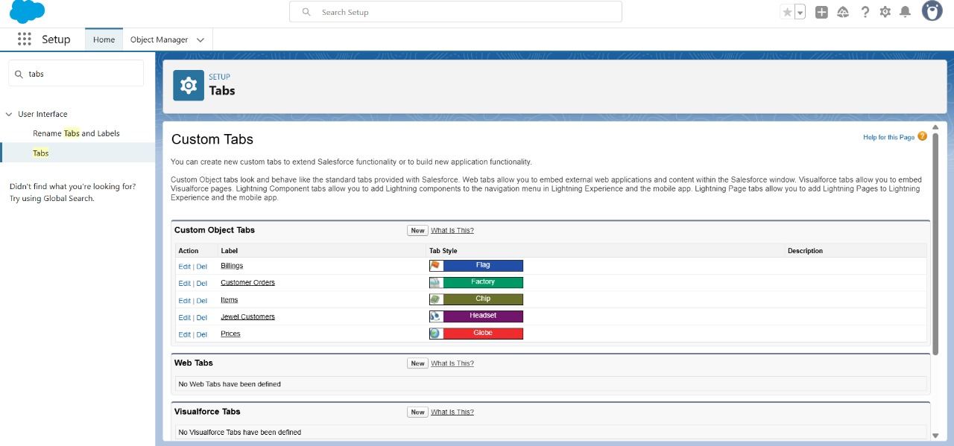

* Created Fields and Relationships

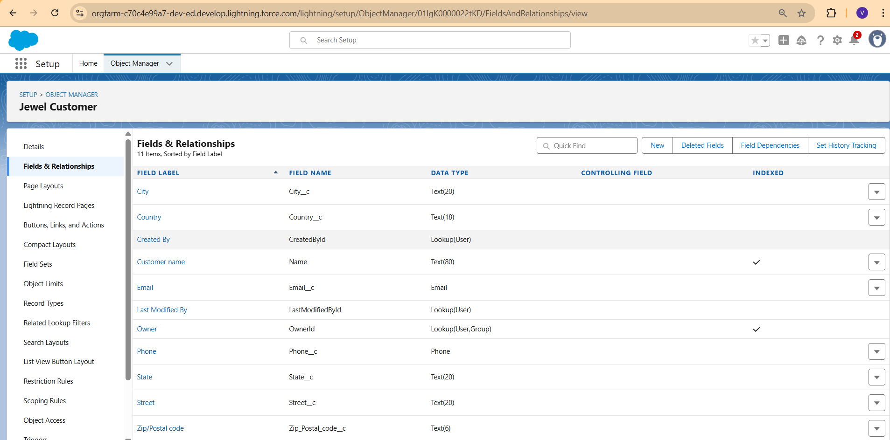

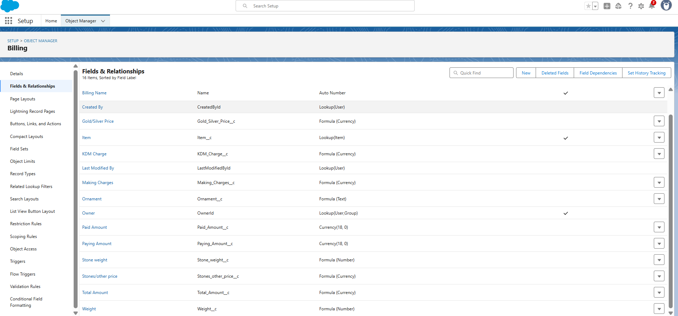

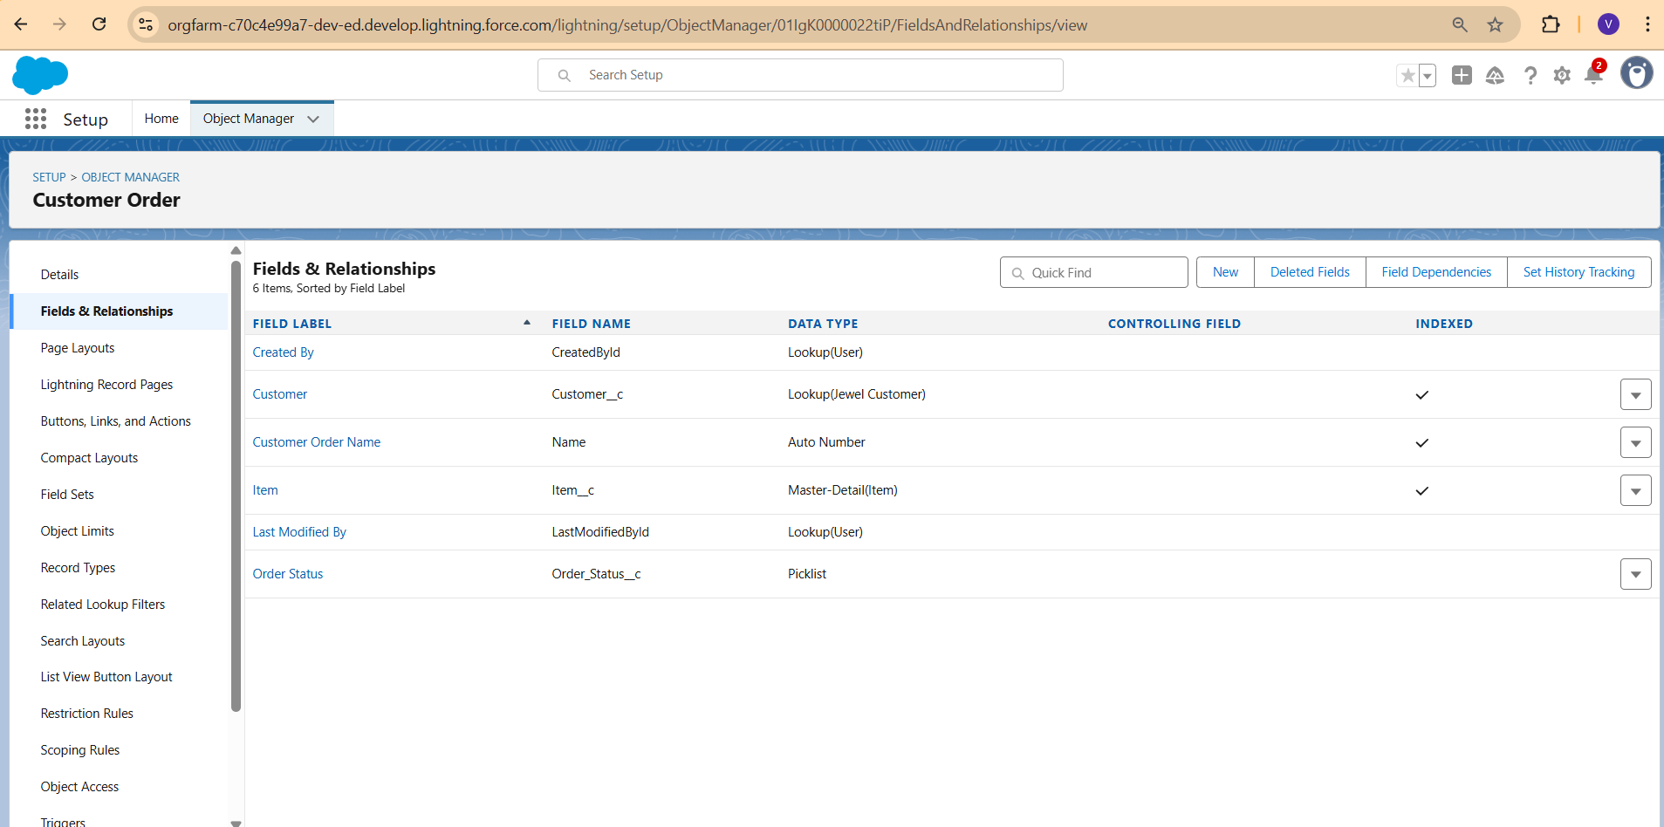

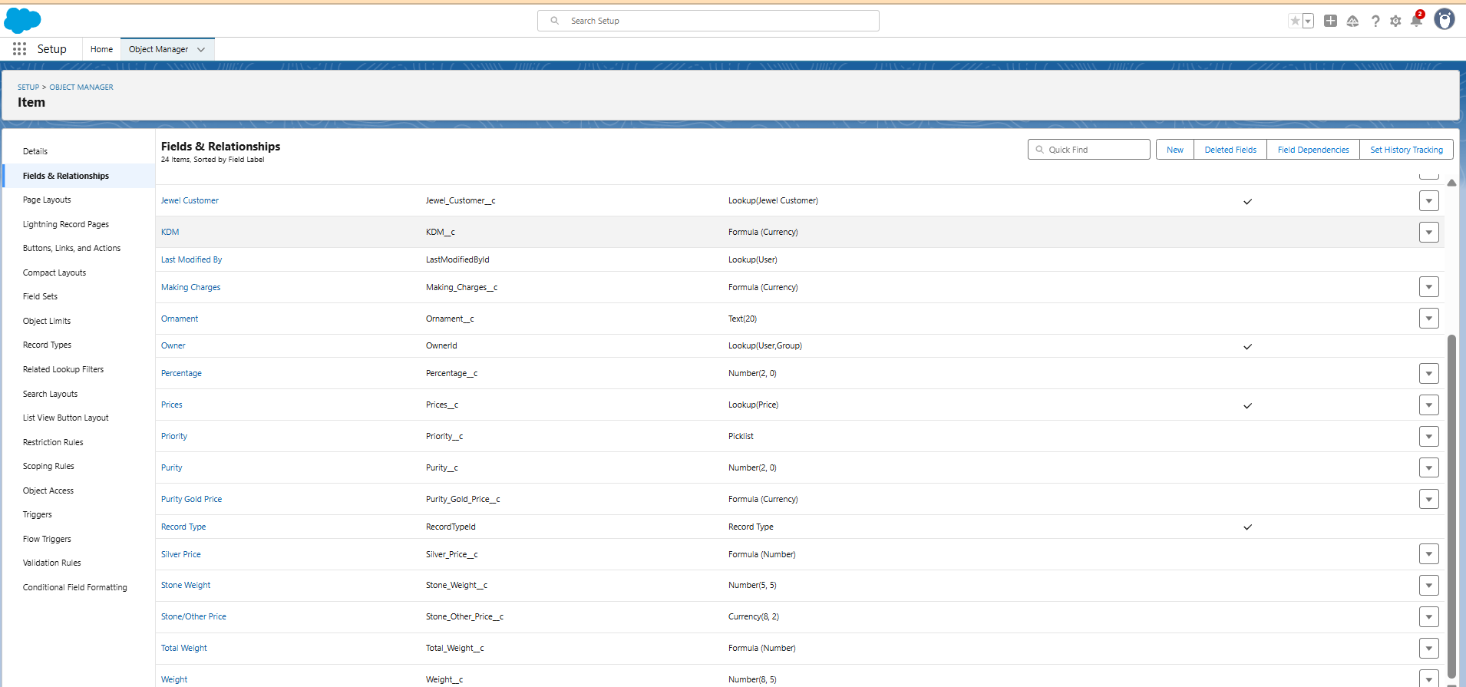

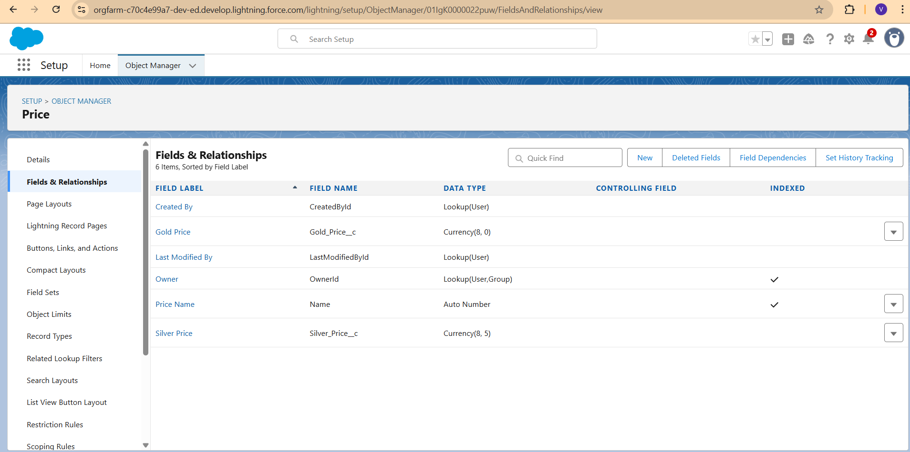

* Developed Lightening App with relevant tabs

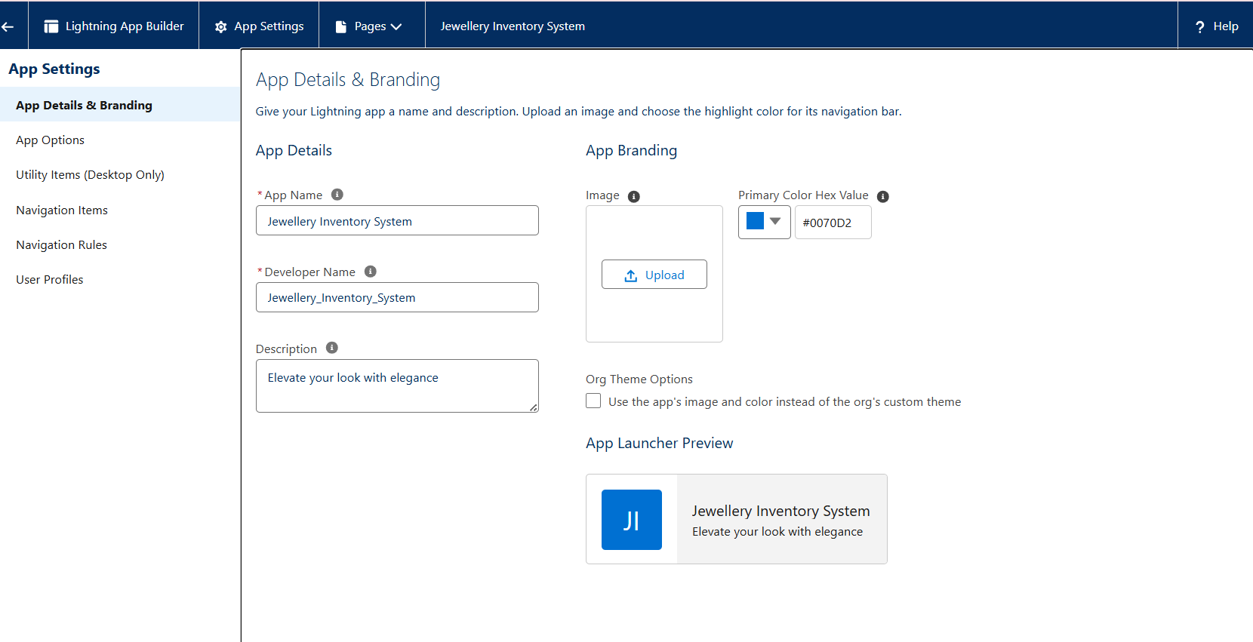

* Custom tabs

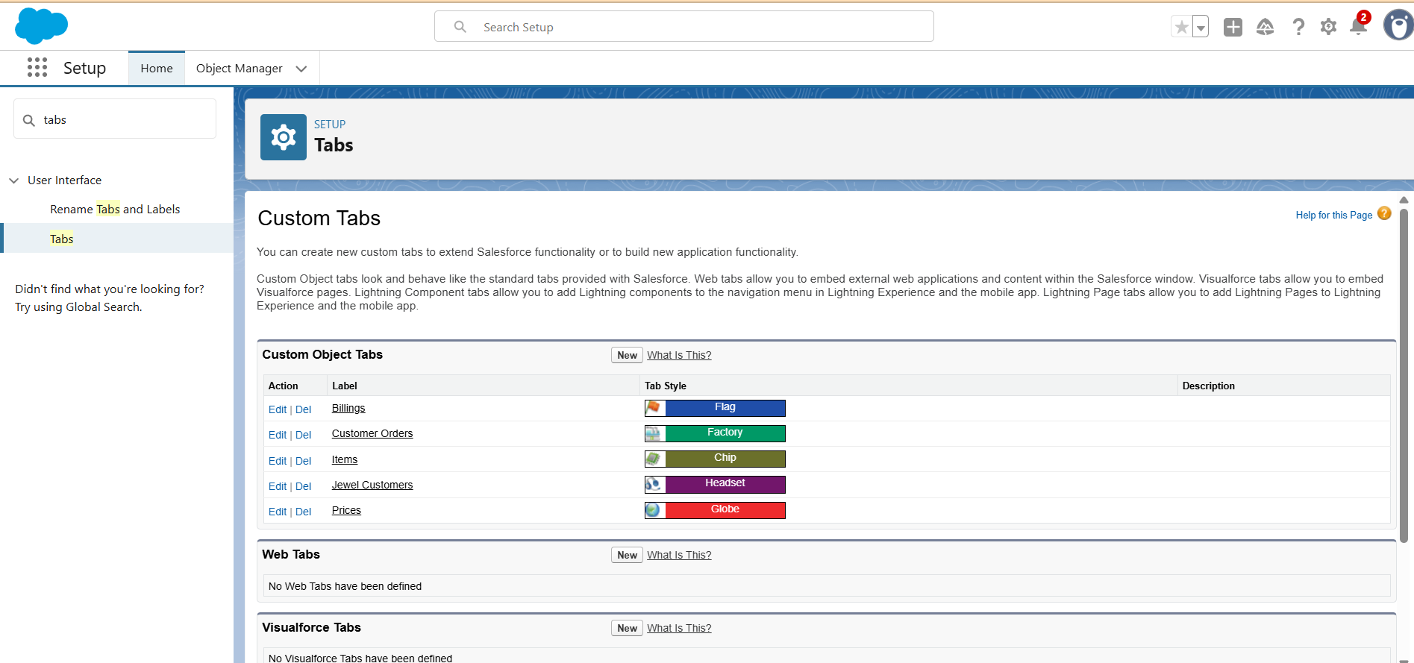

* Validation rules for Jewel Customer and Item object

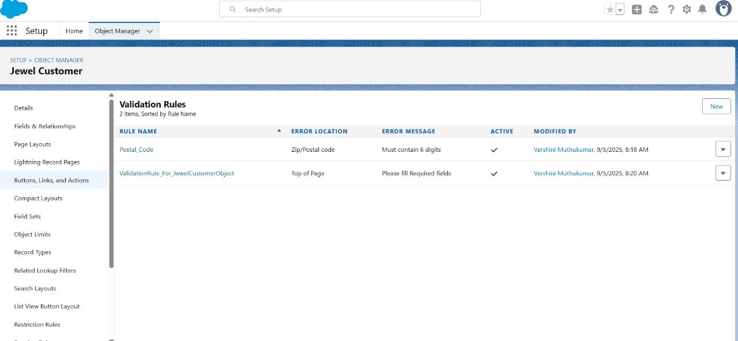

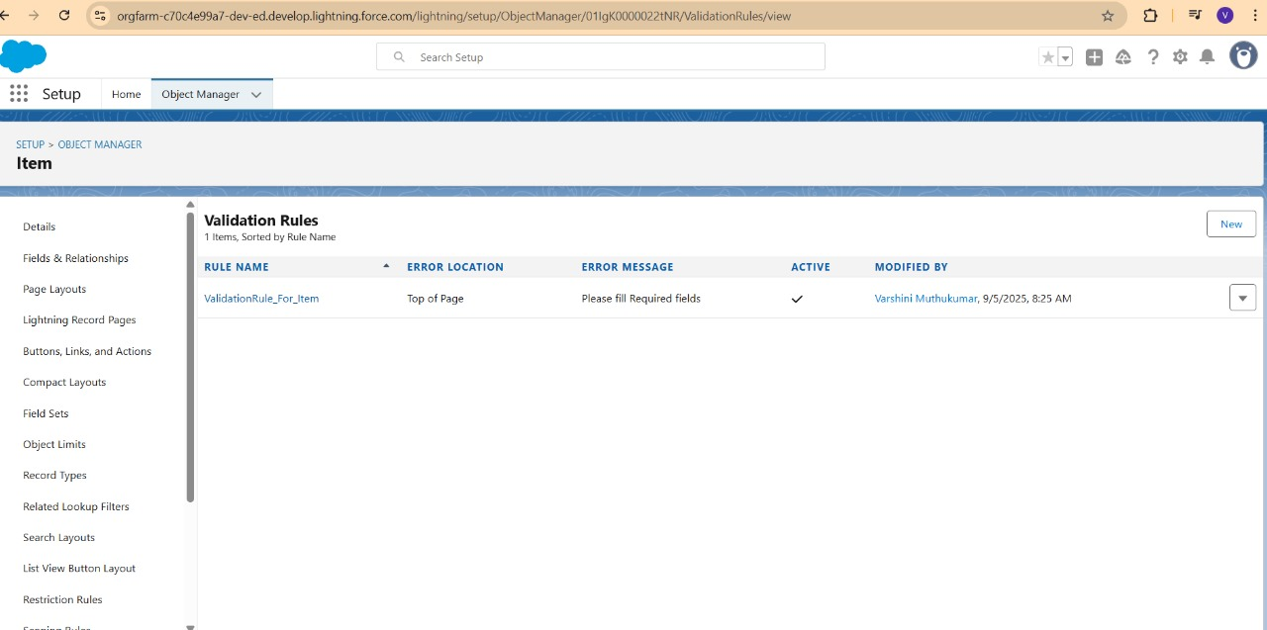

* Created profiles for Gold Smith and Worker

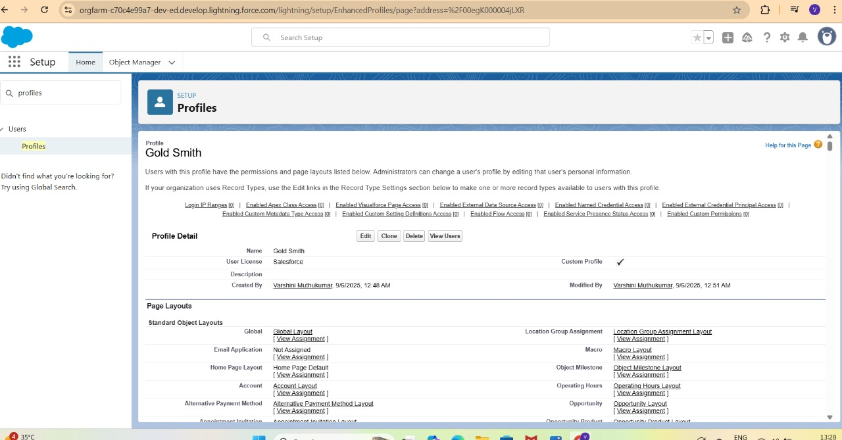

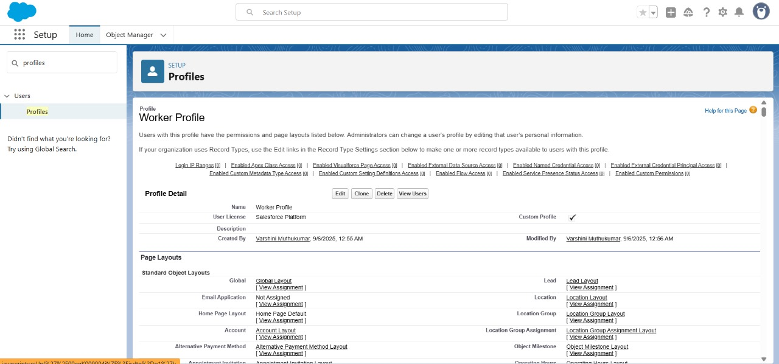

* Created Users

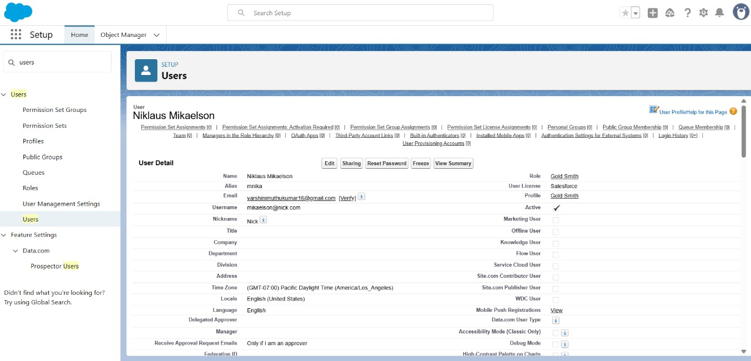

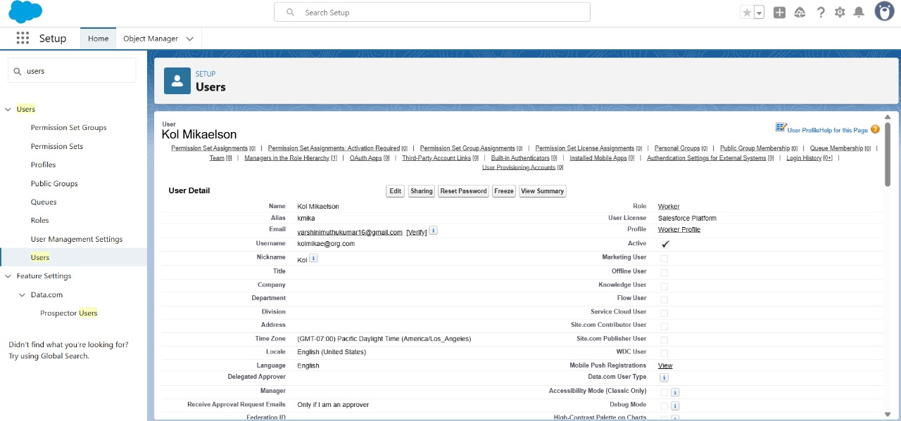

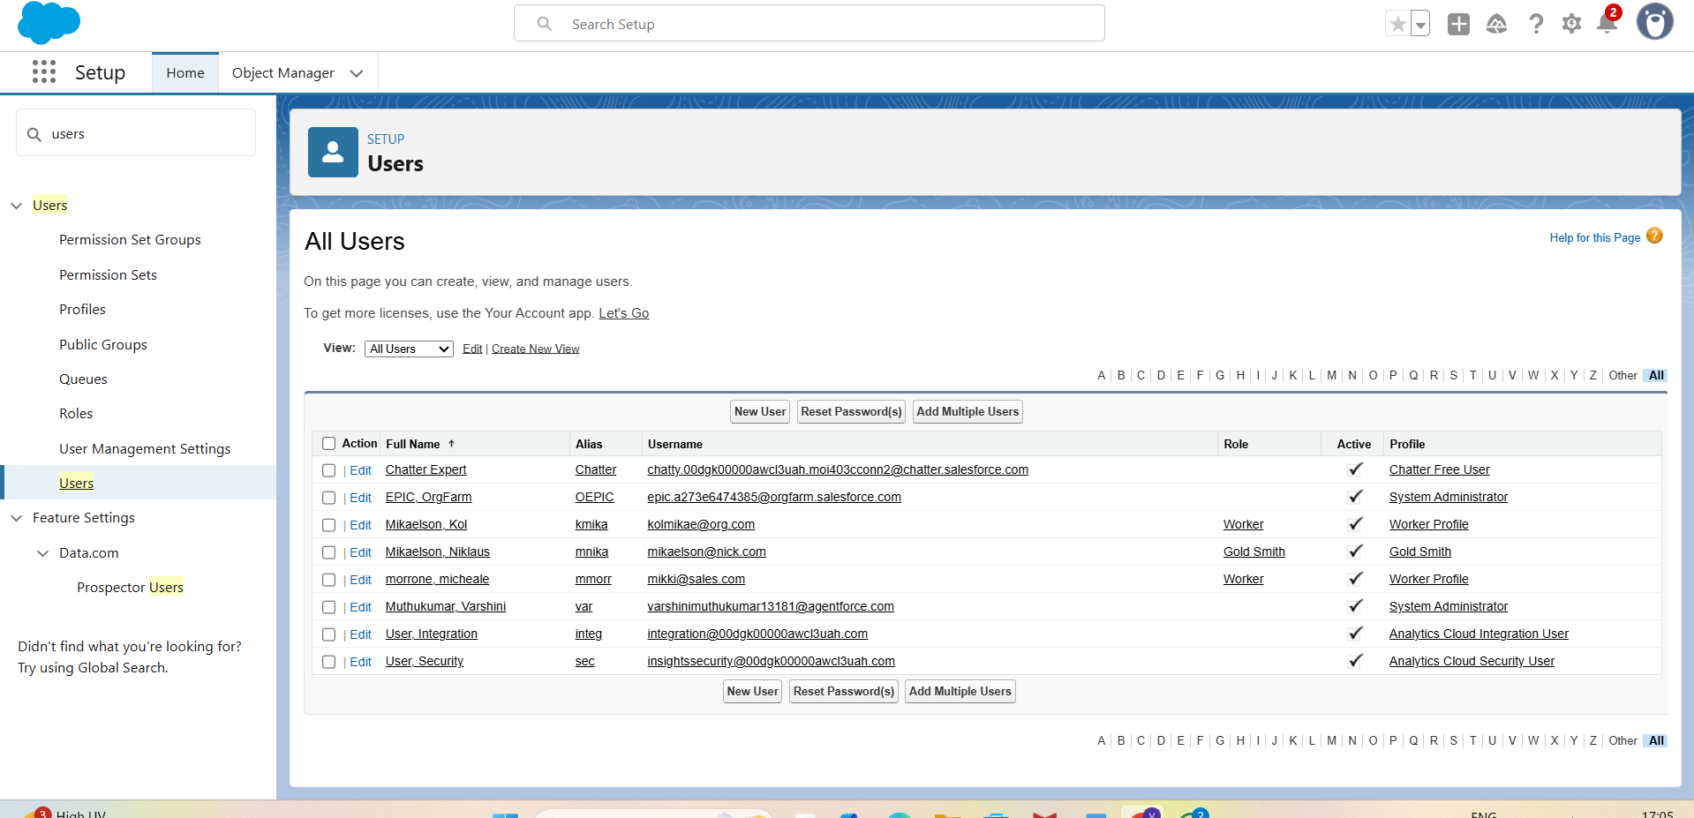

* Roles

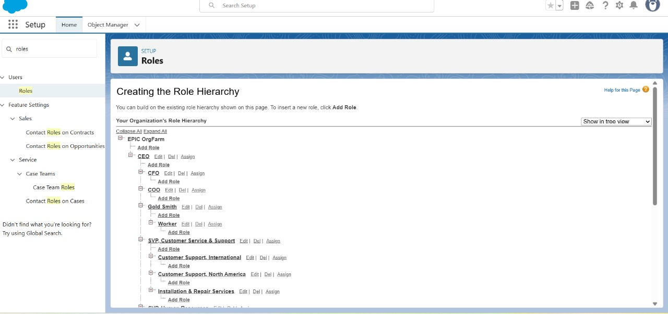

* Created page layouts

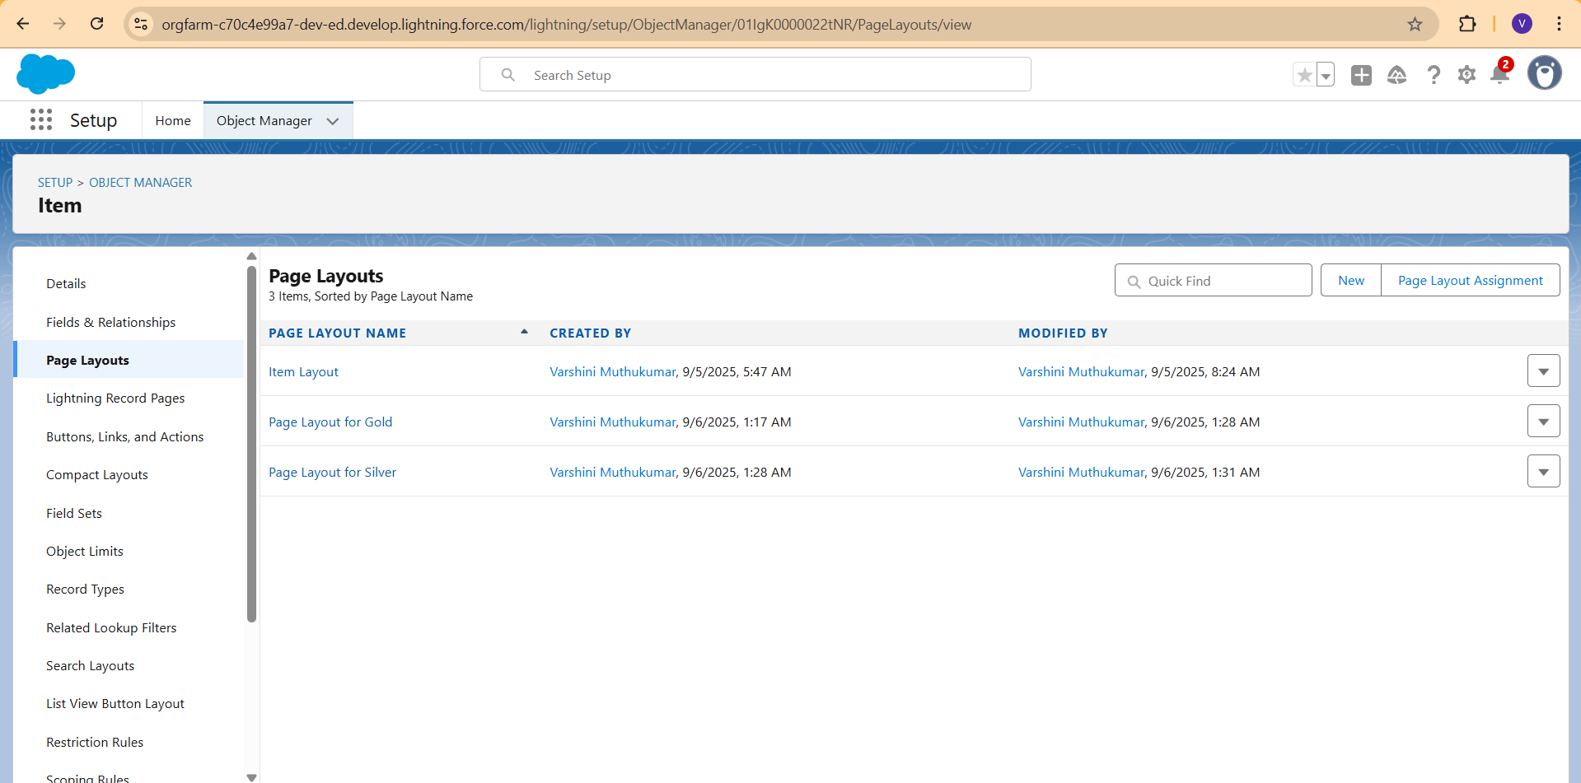

* Created Record Types: Gold and Silver

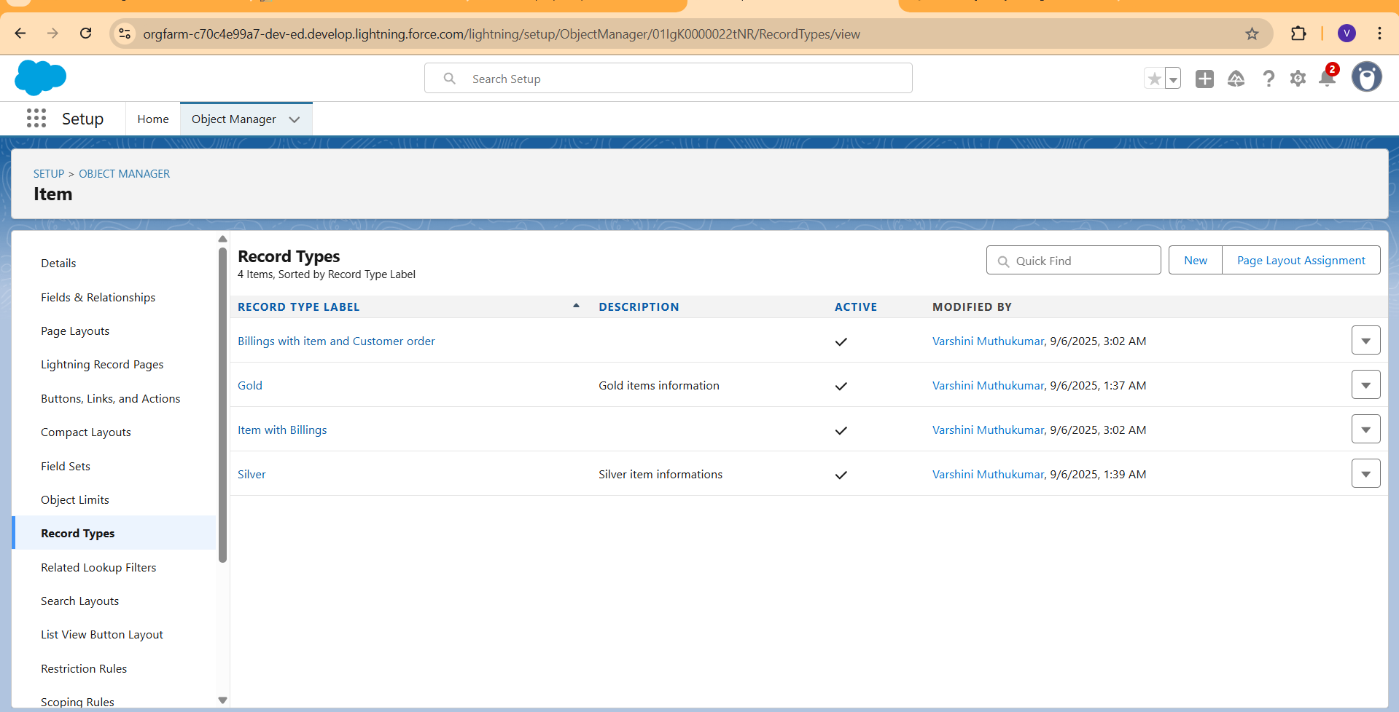

* Permission sets

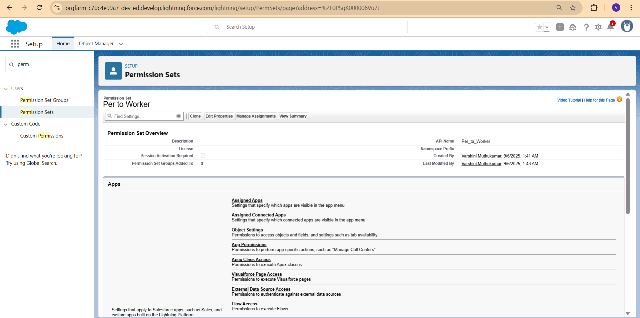

* Created trigger: Update paid amount Trigger

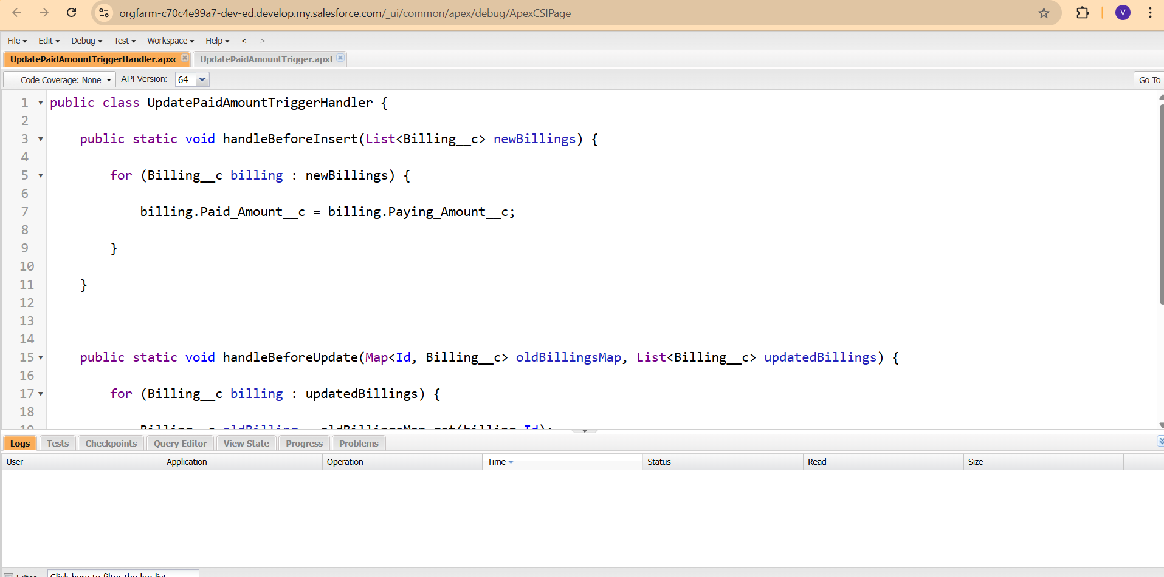

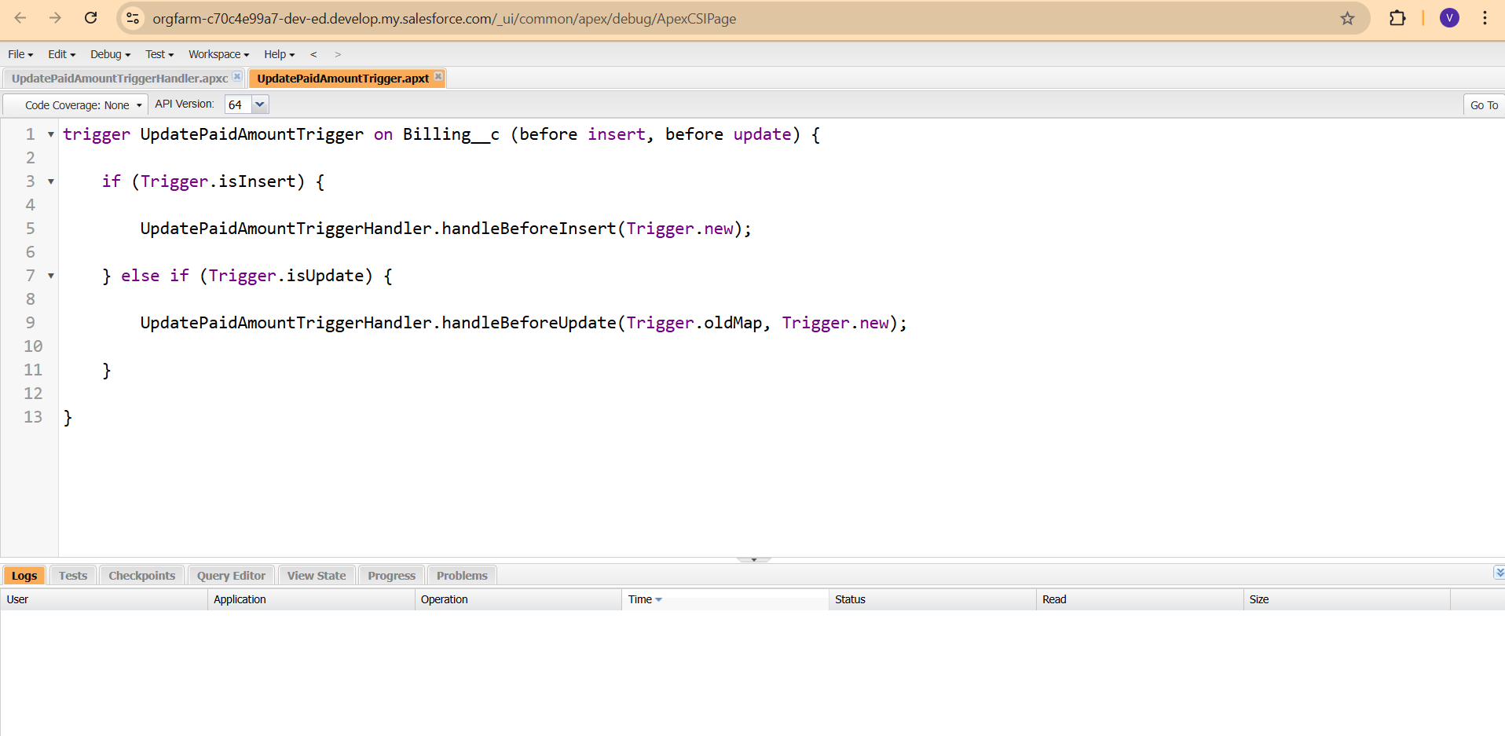

* User Adoption:

1. Create a record
2. View a record
3. Delete a record

* Created Reports: Items with billings and Billing with items and customer order.

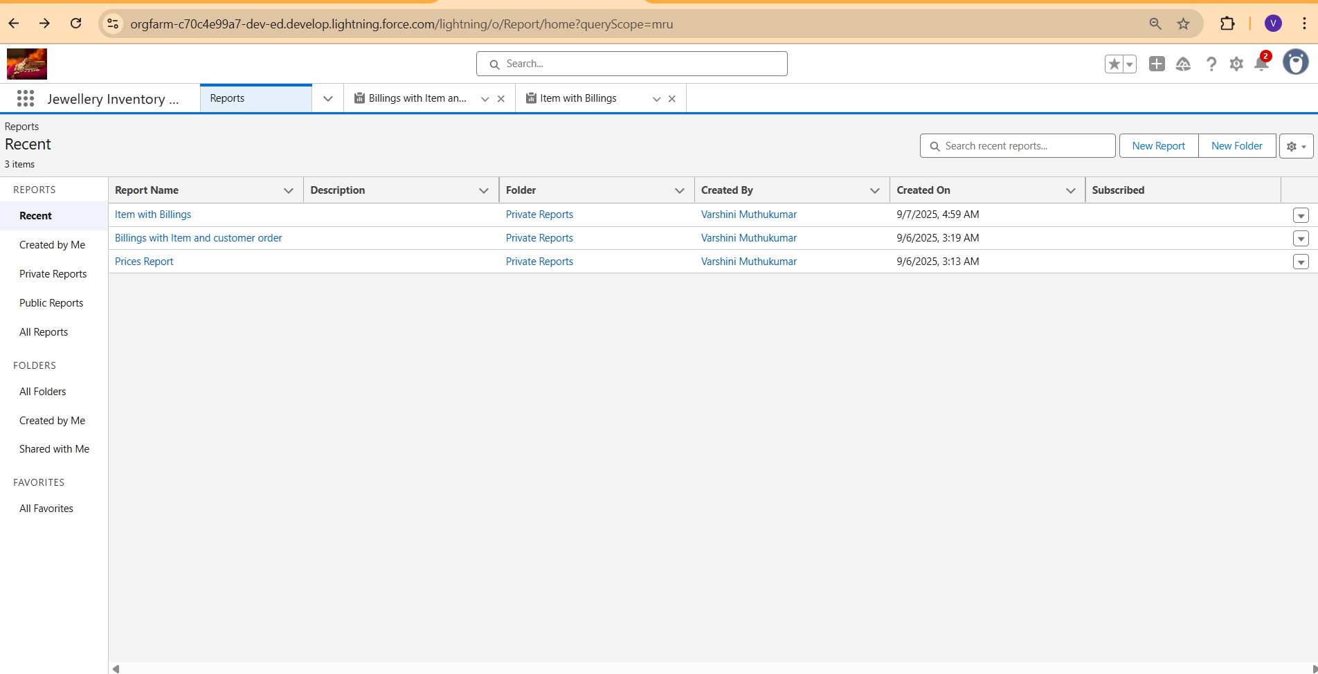

* Dashboards

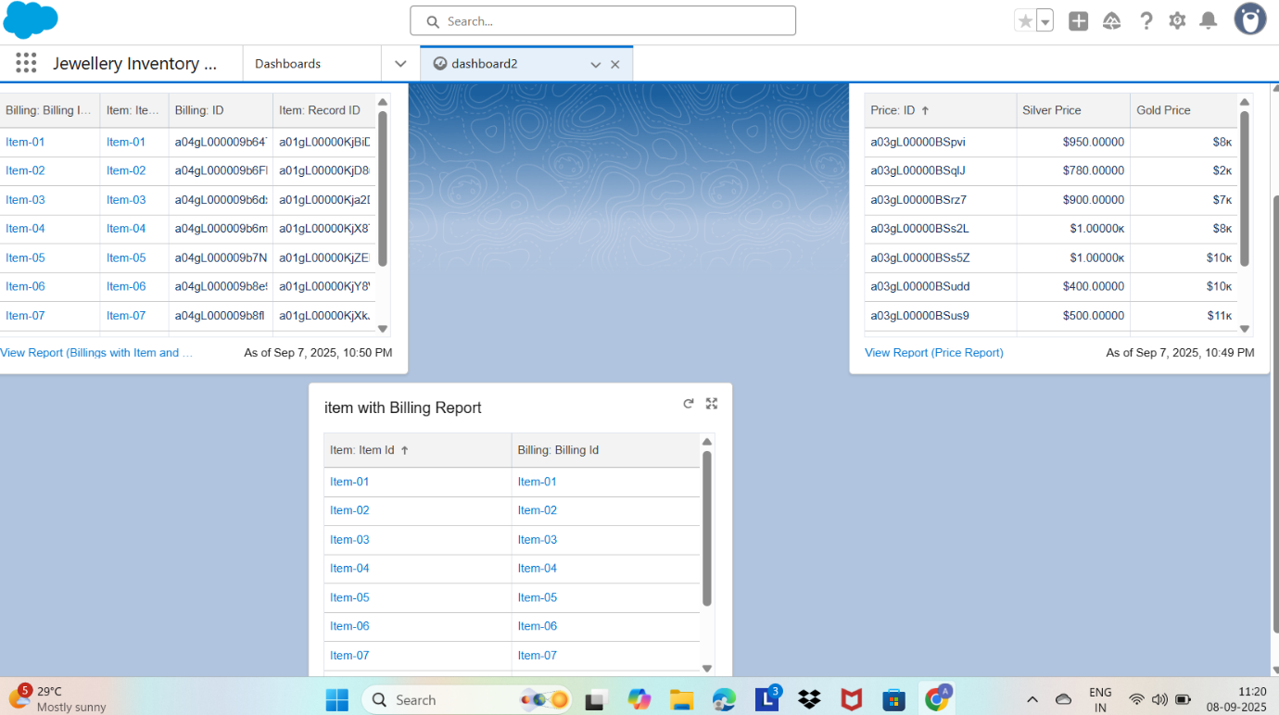

* Created Flow

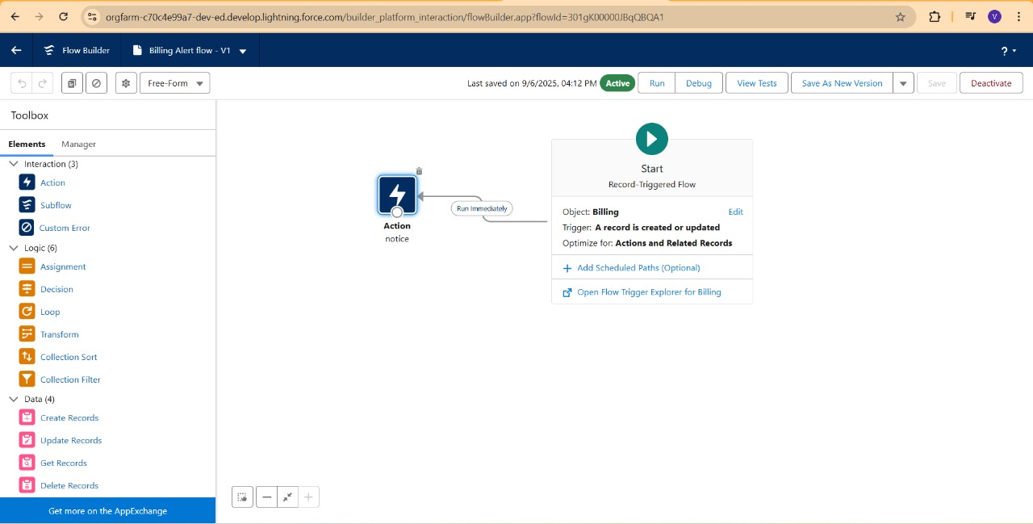

**Conclusion**

**The Jewel Inventory System project demonstrates the power and flexibility of Salesforce in solving real-world business challenges. By integrating custom data models, automation tools, and insightful analytics, the application delivers a complete CRM solution tailored for the jewelry industry.**

**This project not only strengthens technical proficiency in Apex, Lightning Web Components, and declarative tools, but also showcases the ability to translate business needs into scalable, user-friendly solutions. It’s a valuable addition to any developer’s portfolio, reflecting both creativity and practical expertise.**